What is a kindness rock?
Kindness rocks are a trend where people paint rocks or stones with inspirational messages or sayings. By leaving these painted rocks in public places for people to find, you can brighten a stranger’s day with a random act of kindness.

Make Your Own Kindness Rock(s) T oday!
Step 1: Find the Perfect Rock:
You want a nice and smooth rock or stone; this will help make writing on it easier. The size of the rock is important too. Think about how much space your message will take and choose one that’s big enough for all the words.

Step 2: Prep the rock
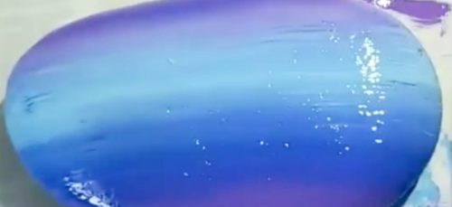
Clean off the rock well with soap and water. Dry completely (sit out in the sun, if possible, to really get it dry). Using an acrylic (non-water base paint) paint, apply a base coat on the rock where you are going to
Step 3: Add an inspirational message
Write a kind message on the rock. These rocks are meant to make people happy, so their phrases should always be positive. Use an idea from the following page, or one of your own.

Step 4: Start placing your rocks around so people can find them!
Place your rocks in a local park, a bench in town, or by the sidewalk near your home. Place your rocks in open spaces, not in places that will disturb nature or ruin a lawnmower.

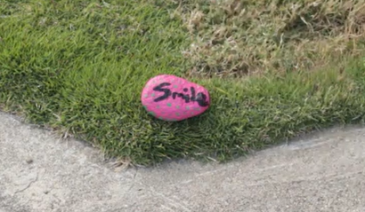
Step 5: HAVE FUN!
Use your creativity and spread these kindness rocks everywhere that you can to pass along lots of smiles to anyone who sees them!

There are obviously ENDLESS things you can write on rocks! These are just some of our favorites to get you inspired.

- You Matter
- You Rock
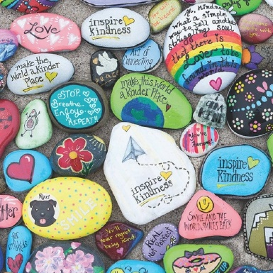
- Be You
- Give Thanks
- Smile
- Live
- Choose Happiness
- Shine Bright
- Be the Light
10. Be Brave
11. Peace
12. Love
13. Be Kind
14. Dream
15. Inspire
16. You are special
17. Good Vibes
18. Hope
19. You Can Do It!
20. Be You!

